Lab1 - Azure Deep Dive Training:

10/12/17

Access Azure Deep Dive Training Subscription

Activity Statements:

Microsft Azure Set up & GitHub Basics

How to create an Ubuntu Linux Machine in Azure Portal

GENERATE SSH KEY PAIR

CREATE A LINUX VM IN AZURE

CONNECT TO YOUR NEW LINUX MACHINE USING CYGWIN

INSTALL and TEST APACHE ON YOUR LINUX VM

Create the VM in Azure

Machine generated alternative text:
https://portal. 
azure.com 
File Edit View Favorites Tools Help 
Token 1 Enter Pin: 
Basics 
Microsoft Azure 
Basic Linux Commands L... McKesson Cloud Program... Shared with me- OneDriv 
SharePoint 
Basics 
Shared with me - OneDrive 
Source of Truth 
PI Planning Leadership 
Q 
Share Browser WebEx 
_ Cloud Denali PI-Planning 
Rick.Hoagland@McK... 
MCKESSON CORPORATION 
Microsoft Azure New 
Dashboard 
All resources 
CO) Resource groups 
App Services 
SQL databases 
SQL data warehouses 
Azure Cosmos DB 
Virtual machines 
Load balancers 
Storage accounts 
Virtual networks 
More services > 
Create virtual machine 
Basics 
Create virtual machine 
1 
2 
3 
4 
Basics 
Done 
Choose virtual machine size 
Settings 
Configure optional features 
Purchase 
Llbuntu Server 16.04 L TS 
* user name 
tazeiga 
* Authentication type 
SS H public key Password 
* SSH public key O 
ssh-rsa 
AAAA33NzaC1yc2EAAQADAQABAQA8A 
QC7s17gEPszHQSUOXp8Vfe5Kt3tY081r 
Subscription 
McKesson Deep Dive Training (4) 
* Resource group 
C) Create new @ use existing 
grant_D eepAzure_ H WOI 
* Location 
East US 2 

Disk, Network and IP Address and Resource group

Machine generated alternative text:
https::fpcrtal. 
azure.com 
File Edit View Favorites Tools Help 
Token 1 Enter Pin: 
Settings 
Microsoft Azure 
Basic Linux Commands L... McKesson Cloud Program... Shared with me- OneDriv 
SharePoint 
Settings 
Shared with me - OneDrive 
Source of Truth 
PI Planning Leadership 
Q 
Share 8 rowser WebEx 
_ Cloud Denali PI-Planning 
Rick.Hoagland@McK... 
MCKESSON CORPORATION 
Microsoft Azure New 
Dashboard 
All resources 
CO) Resource groups 
App Services 
SQL databases 
SQL data warehouses 
Azure Cosmos DB 
Virtual machines 
Load balancers 
Storage accounts 
Virtual networks 
More services > 
Create virtual machine 
Settings 
Create virtual machine 
1 
2 
3 
4 
Basics 
Done 
Done 
Settings 
Configure optional features 
Purchase 
Llbuntu Server 16.04 L TS 
High availability 
-k Availability set O 
None 
Storage 
use managed disks O 
Network 
* Virtual network O 
(new) grant_DeepAzure_HW01484 
* Subnet O 
default (10.0.1.0/24) 
* Public IP address O 
(new) tazei9a-UbuntuServ•er1604... 
* Network security grcnup (firewall) O 

Purchase Details

Machine generated alternative text:
https:fi'pcrtal. 
azure.com 
File Edit View Favorites Tools Help 
Token 1 Enter Pin: 
Purchase - 
Basic Linux Commands L... McKesson Cloud Program... Shared with me- 
One Driv 
Microsoft Azure 
SharePoint 
Purchase 
Shared with me - OneDrive 
Source of Truth 
PI Planning Leadership 
Share Browser WebQ 
_ Cloud Denali PI-Planning 
Rick.Hoagland@McK... 
MCKESSON CORPORATION 
Microsoft Azure New 
Dashboard 
All resources 
CO) Resource groups 
App Services 
SQL databases 
SQL data warehouses 
Azure Cosmos DB 
Virtual machines 
Load balancers 
Storage accounts 
Virtual networks 
More services > 
Create virtual machine 
> Purchase 
Create virtual machine 
1 
2 
3 
4 
Basics 
Done 
Done 
Settings 
Done 
Purchase 
Llbuntu Server 16.C4 L TS 
O 
Validation passed 
Offer details 
Prices presented are estimates in )R3ur local currency that include only Azure 
infrastructure costs and any discounts for the subscription and location. The prices 
don't include any applicable software costs. 
Ubuntu Serv•er 16.04 LTS 
by Canonical 
Terms of use I privacy policy 
Standard DI v2 
by Microsoft 
Terms of use I privacy policy 
Terms of use 
Pricing details 
0.0502 USD/hr 
Pricing for other VM sizes 
o 
ay clicking "Purchase", I (a) agree to the legal terms and privacy statement(s) associated with 
ach Marketplace offering above, (b) authorize Microsoft to charge or bill my current payment 
method for the fees associated with my use of the offering(s), including applicable taxes, with the V 
me billin 
as Azure subscri ion, untill discontinue use of the offeri (s), (c) 
Purchase 
Download template and parameters 
1228 PM 
10/12/2017 

Azure Deploying Server

Machine generated alternative text:
https:,'/portal. 
azure.com 
File Edit View Favorites Tools Help 
Token 1 Enter Pin: 
Dashboard 
Basic Linux Commands L... McKesson Cloud Program... Shared with me- OneDriv 
Microsoft Azure 
SharePoint Shared with me- OneDrive Source of Truth PI Planning Leadership 
Share Browser WebQ 
_ Cloud Denali PI-Planning 
Rick.Hoagland@McK... 
MCKESSON CORPORATION 
Microsoft Azure 
Dashboard 
All resources 
CO) Resource groups 
App Services 
SQL databases 
SQL data warehouses 
Azure Cosmos DB 
Virtual machines 
Load balancers 
Storage accounts 
Virtual networks 
More services > 
Dashboard V + New dashboard 
All resources 
MCKESSON DEEP DIVE TRAINING (4) 
p Search resources, services and docs 
Edit dashboard Share Fullscreen 
Clone 
Quickstart tutorials 
C) Refresh 
Delete 
g ra nt_DeepAzu re_HWOI - v net 
grant-deepazure-hw01159 
grantdeepazurehw01539 
grant-DeepAzure-HWOI-VM 
grant-DeepAzure-HWOI-VM-ip 
Service Health 
Virtual network 
Neüork interface 
Storage account 
Virtual machine 
Public IP address 
Neüork security grou 
Windows Virtual Machines Z 
Provision Windows Server, SQL Server, SharePoint VMS 
Linux Virtual Machines Z 
Provision Ubuntu, Red Hat, Centos, SLISE, CoreOS VMS 
App Service Z 
Create Web Apps using .NET, Java, Node.js, PH? 
Functions Z 
Process events With a serverless code architecture 
SQL Database Z 
Managed relational SQL Database as a Service 
RH-DataFactory 
DATA FACTORY 
Help * support 
Quickstart tutorials 
Deploying Ubuntu Server 
1604 LTS 
Windows Virtual Machines Z 
1228 PM 
10/12/2017 

Running VM

Machine generated alternative text:
https 
://pcrtal. 
azure.com 
File Edit View Favorites Tools Help 
Token 1 Enter Pin: 
Dashboard 
Microsoft Azure 
SharePoint 
Basic Linux Commands L... McKesson Cloud Program... Shared with me- OneDriv 
Microsoft Azure 
tazeiga-UbuntuServer1604LTSAzureDeepDive 
Shared with me - OneDrive 
Source of Truth 
Capture 
PI Planning Leadership 
Share Browser WebEx 
_ Cloud Denali PI-Planning 
Rick.Hoagland@McK... 
MCKESSON CORPORATION 
tazei9a-UbuntuServer1604LTSAzureDeepDive 
Virtual 
Dashboard 
All resources 
CO) Resource groups 
App Services 
SQL databases 
SQL data warehouses 
Azure Cosmos DB 
Virtual machines 
Load balancers 
Storage accounts 
Virtual networks 
More services > 
Search (Ctr/+/) 
Overview 
Activ log 
Access control LAM) 
Tags 
Diagnose and solve problems 
Networking 
Disks 
Extensions 
Availability set 
Connect Start 
Resource group 
Status 
Running 
Location 
East US 2 
Subscription 
Restart 
McKesson Deep Dive Training (4) 
Subscription ID 
86d62b86-1ed2-45c1-8f6c-164cgb3db93a 
Stop 
12 hours 
Delete Refresh 
Computer name 
tazeiga-lJ bu n tuServer1604LTSAzureDeepDive 
Operating system 
Linux 
Size 
Standard DI v2 (I vcpu, 3.5 G8 memory) 
Public IP address 
5222254207 
Virtual network/subnet 
gra n t_ DeepAzure_HW01484/defau It 
Show data for last: 
CPU (average) 
I hour 
6 hours 
I day 
7 days 
DNS name 
Configure 
30 days 
Network (total) 
Icos 
1231 PM 
10/12/2017 

ssh to [tazei9a@52.232.254.207](mailto:tazei9a@52.232.254.207) – command prompt

Machine generated alternative text:
deepazure.s... 
File Edit 
e http:,•',•'cleepazure.a. 
amazonaws. 
Go to 
Favorites Help 
Token 1 Enter Pin: 
Basic Linux Commands McKess 
w Deep Azure Trainim 
ECOSA key fingerprint is 
Are you sure you want to continue connecting (yes/no)? yes 
Warning: Permanently added '52. 232. 254. 207' (ECDSA) to the list of known hosts. 
Welcome to Llbuntu 16.04.3 L TS (GNU/ Linux 4.11.0-1011-azure x86_64) 
Documentation : 
https : // help. ubuntu.com 
Management : 
Support : 
https : // I andscape. canonical.com 
https ://ubuntu . com/advantage 
Get cloud support with Llbuntu Advantage Cloud Guest: 
http://"%'. ubuntu.com/business/servi ces/cloud 
O packages can be updated. 
O updates are security updates. 
The programs included with the Llbuntu system are free software; 
the exact distribution terms for each program are described in the 
individual files in /usr/share/doc/*/copyright. 
Ubuntu comes with ABSOLUTELY W WARRANTY, to the 
extent permitted by 
applicable law. 
To run a connand as administrator (user "root") , 
use "sudo 
See "man sudo_root" for details. 
tazei gaatazei ga- UbuntuServer1604 L TSAzur eDeepDive : — 
,nercuNrdrca-HP "h 
henticity of '52.170.25. 62.170.26.89) 
fingerprnnt 
connecting 
'52.170.26.09' (ECD5A) to th 
to ubuntu 18.01.3 L Ts *.11.0-1011 -azure xgs_64) 
e http://deepazure.s... 
Dashboard - 
Share Browser WebEx 
of Truth PI Planning Leadership- E... Cloud Denali PI-Planning 
ygwin 
nection 
ould like 
' cen't 
e cf knm•n h 
e http://deepazure.s... 
Billing - Internet Em 
Azure Linux Virtualm 

Install Apache2 on VM

Machine generated alternative text:
File Edit 
q packagu will 
e http://cleepazure.a. 
amazonaws.com 
Go to 
Favorites Help 
Token 1 Enter Pin: 
Basic Linux Commands L... McKesson Cloud Program... Shared with me- OneDriv. 
SharePoint Shared with 
C tazeiga@tazeiga-UbuntuSer.'er16C4LTSAzureDeepDive: 
q lite3 amd64 1. 5.4-1buiIdI 
[10.6 k8] 
Get http://azure. archive. ubuntu.com/ubuntu 
amd64 1. 5.4-1bui1d1 [8,720 8] 
Get:5 http://azure. archive. ubuntu.com/ubuntu 
5.1.5-8ubuntu1 [102 k8] 
Get: 6 http://azure. archive. ubuntu.com/ubuntu 
in amd64 2.4.18-2ubuntu3.5 
[925 k8] 
Get: 7 http://azure. archive. ubuntu.com/ubuntu 
t i Is amd64 2.4.18-2ubuntu3. 
5 [82.3 k8] 
Get: 8 http://azure. archive. ubuntu.com/ubuntu 
ata all 2.4.18-2ubuntu3.5 [162 k8] 
Get: 9 http://azure. archive. ubuntu.com/ubuntu 
md64 2.4.18-2ubuntu3.5 [86.7 k8] 
xenial/main amd64 libapruti Il-Idap 
xenial/main amd64 IibIua5.I-O amd64 
xenia I -updates/main amd64 
apache2-b 
xenia I -updates/main amd64 
apache2-u 
xenia I -updates/main amd64 
apache2-d 
xenia I -updates/main amd64 
apache2 
• 
Install Ap 
• Get http://azure. archive. ubuntu.com/ubuntu xenial/main amd64 ssl-cert all I. 
.37 (16.9 ka] 
Fetched 1,557 ka in Is (1,454 kais) 
Preconfiguring packages 
Selecting previously unselected package libaprI:amd64. 
(Reading database . 
Install Apache on Cygwin by t 
your Cygwin command prompt: 
$ u o ap -ge —Y 
sudo aft-cet 
Rrm+no 
Ins a apac e 
zøache2 
aoache2-bin azache2-data aoache2-ut71s 
I-ibaorl libaørutill 
I-ibaprut-ill-ldzø 
0'5.1-0 "I-cert 
package will be installed: 
aoache2 a.ache2-bin aoache2-data aøache2-uti1s libaørl libaørutill 
u,5.1-n 
O -10 
to 1,557 
'*ter this 
Cet:1 
[86.0 
Get ; 2 httø • 
6,432 ke of 
ore U chive ubuntu. 
[77.1 
Get 23 
amde-4 1. s.4-Lbui1d1 CIO. 6 k6J 
Cct:4 http: 
a-chive u buntu. 
1.5.2-3 
1.5. 
bagruti 

Roger, Apache2 installed

Machine generated alternative text:
Deep Azure Tr„. 
File Edit 
env. 
mime. 
libc-b-in 
e http:,•',•'cleepazure.a. 
amazonaws.com 
Go to 
Favorites Help 
Token 1 Enter Pin: 
Week I: 
SharePoint 
O Yo 
Shared with 
C tazeiga@tazeiga-UbuntuSeNer1604LTSAzureDeepDive: 
Enabling conf localized-error-pages. 
Enabling conf other-vhosts-access-log. 
Basic Linux Commands L... McKesson Cloud Program... Shared with me- OneDriv. 
Enabling conf security. 
Enabling conf serve-cgi-bin. 
Enabling site 000-default. 
Setting up ssl-cert (1.0. 37) 
sent inval idate(group) request, 
sent inval idate(passwd) request, 
sent inval idate(group) request, 
sent inval idate(group) request, 
sent invalidate(group) request, 
exi ti ng 
exiting 
exiting 
exiting 
exiting 
Start Apa 
Start Apache on Cygwin by typing t 
Cygwin command prompt: 
$sudo /etc/init.d/apache2 start 
Processing triggers for Iibc-bin (2. 23-0ubuntu9) . 
Processing triggers for systend (229-4ubuntu19) 
Processing triggers for ureadahead (0.100.0-19) 
Processing triggers for ufw (O. 35-0ubuntu2) 
sudo / etc/init. d/ apache2 sta 
C ok ] Starting apache2 (via systenctl): apache2. servi ce. 
tazei gaatazei ga- UbuntuServer1604 L TSAzur eDeepDive : —S 
_nabl ing 
_ n Abling 
n 01 inq 
_nabl ing 
_ n Abling 
inq 
-nab 1 inq 
_ n Abli 
Enabling 
—nab 1 inq 
ing 
Fr. dbl -i 
n *got i At 
set enviF 
oth« I 
000_deFnu1t, 
p cert (1.0.37) 
dat 
dat 
invnl-idnt (g 
essfng 
t c urn stanwB rt . 
request , 
request , 
request , 
roup) 
(2.23-0ubuntu3) . 

Opened Port 80 for inbound access to Ubuntu

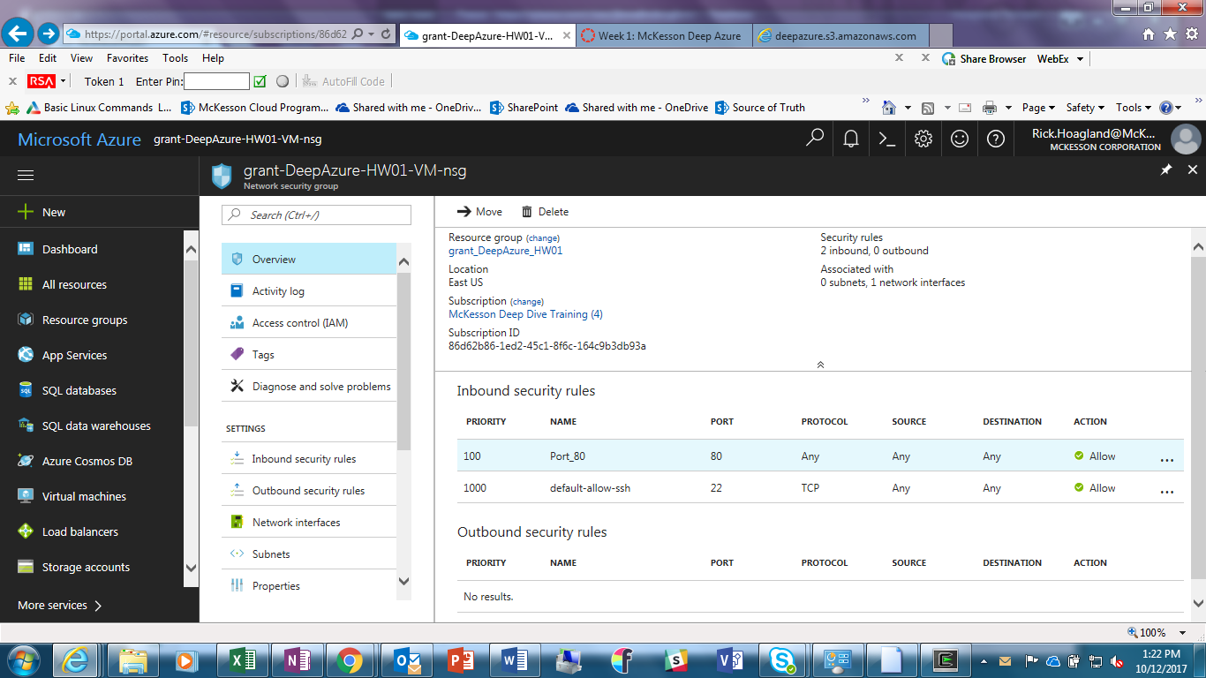

And, display of Apache2 Ubuntu Default Page from server 52.232.254.207 -

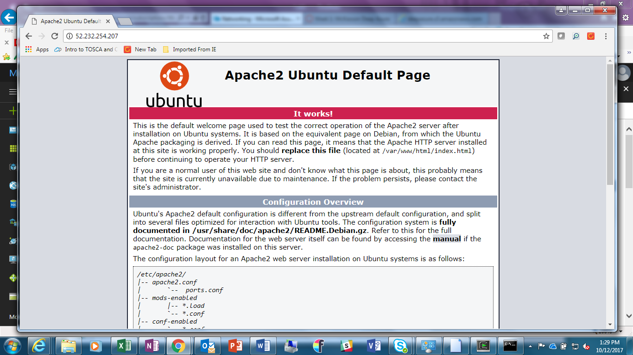

Clean up the environment. (Go Green)

